More Stroke Resources

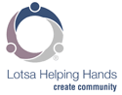Lotsa Helping Hands
Lotsa Helping Hands offers free tools to coordinate care and make life easier for caregivers. Tools include a help calendar, which enables members to schedule and sign up for tasks that provide respite for the caregiver, plus message boards, personal blogs, photo sharing, and information and records storage.

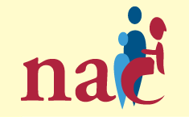National Alliance for Caregiving
The National Alliance for Caregiving was created to conduct research, do policy analysis, develop national programs, increase public awareness of family caregiving issues, work to strengthen state and local caregiving coalitions, and represent the US caregiving community internationally.

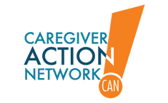Caregiver Action Network
Caregiver Action Network (CAN) provides education, peer support, and resources for family caregivers.

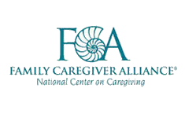Family Caregiver Alliance
Family Caregiver Alliance addresses the needs of families and friends providing long-term care for loved ones at home.

